
SUNDAY, MAY 12 MOTHER’S DAY
Traditional Worship Services - 8:30
Contemporary Worship Service - 11:00 AM
Sunday School for All Ages - 9:45 AM
Wee Chapel & Children’s Church – 11:00 AM
Softball Practice Canceled this week
Chi Alpha Ensemble Rehearsal - 3:00 PM
Chi Alpha Youth Choir – 4:00 PM
Children’s Choirs – 4:30 PM
MONDAY, MAY 13
Softball Game – 6:00 & 7:15 PM
Sign Language Intermediate – 6:00 PM
Sign Language Beginning – 7:00 PM
TUESDAY, MAY 14
NDFY Singers Rehearsal – 9:30 PM
WEDNESDAY, MAY 15
Ladies Morning Bible Study – 10:00 AM
Bible Immersion Group - 3:00 PM
Wednesday Supper – 5:00 PM
Ladies Evening Bible Study – 5:30 PM
Youth – 6:00 PM
Jubilate Choir – 6:30 PM
UPCOMING EVENTS
VBS Meeting May 19 Right after 11:00 service
Children’s Choirs Spring Program – May 19
First Place Orientation – May 20
NDFY May Meeting – May 28 -10:30 AM
Calico Evening Worship June 9 – 6:30 PM

Calendar
Dr. Eddie Pate
Senior Pastor
eddiepate@fbcbarstow.com

Jerry Green
Pastor of Worship and Ministry
geraldo.green@verizon.net

Andy & Hannah Ellis
Youth Ministry Coordinators
h_a_ellis@yahoo.com

Michelle Sibole
Children’s Ministry Coordinator
michellesibole@fbcbarstow.com

First Baptist Church
1320 Barstow Rd./P. O. Box 625
Barstow, CA 92311
(760) 252-2949

Church Office Hours
Monday–Thursday: 9:00 AM–4:00 PM
Closed for lunch 12:00–1:15
Friday: 9:00 AM to 12:00 Noon
Website www.fbcbarstow.com
Email fbc.barstow@verizon.net

First Baptist Prayer Chain
Contact Jane Lupac, 760-252-3946

Sign Language provided during the 8:30 worship service

Fellowship
Hall
Youth
Room
Education Building
Nursery
(2nd Floor)
Men
Worship
Center
Choir
Room
Cry
Room
Office
Women

APRIL 7, 2013

Where people like to go to church
May 12, 2013



Sermon Series

1) Introduction to Spiritual Disciplines
2) Solitude, Silence and Secrecy
3) Fasting, Frugality and Chastity
4) Study, Meditation and Memorization
5) Worship, Celebration and Prayer
6) Service, Submission and Fellowship
Have nothing to do with godless myths and old wives tales; rather, train yourself to be godly. For physical training is of some value, but godliness has value for all things, holding promise for both the present life and the life to come. I Timothy 4:7 & 8


For questions or comments about today's
message tweet #fbcbarstow
May 12, 2013
Please disengage audible alarms on cell phones before the service.
Worship
8:30 A.M.

SINGING TOGETHER
TIME OF FELLOWSHIP
WELCOME & CHURCH NEWS
CHORAL SONG
VIDEO
SINGING TOGETHER

WORSHIP THROUGH GIVING
CHORAL SONG

SINGING TOGETHER
LORD’S SUPPER
WORSHIP THROUGH THE WORD

HYMN OF COMMITMENT
CLOSING PRAYER
PARTING CHORUS
“Great Is the Lord Almighty”

Pastor Eddie
“Bring us Back” Not Done For Yet Singers
“My Mom”
“She Will Be Called Blessed”
“Would You Bless Our Homes & Families”
“The Family Prayer Song”
Prayer: Steve Depue
“I’ll Leave it All Behind”
Not Done for Yet Singers
“Firm Foundation”

Session 5 – Worship, Celebration & Prayer
Pastor Eddie
“The Family Prayer Song”
Prayer: Steve Depue
“She Will Be Called Blessed”

11:00 A.M.

WORSHIP IN SONG
WELCOME & CHURCH NEWS
CHORAL SONG

WORSHIP IN SONG
TIME OF FELLOWSHIP
VIDEO
WORSHIP IN SONG
WORSHIP IN GIVING
CHORAL SONG

LORD’S SUPPER
WORSHIP IN SONG
WORSHIP IN THE WORD

WORSHIP IN COMMITMENT
PARTING CHORUS
“Rock of Ages”
Pastor Eddie
“Bring Us Back”
Not Done For Yet Singers
“Great is the Lord Almighty”

“My Mom”
“She Will Be Called Blessed”
Prayer: Ken DeVries
“I’ll Leave It All Behind”
Not Done for Yet Singers

“10,000 Reasons”
Session 5 – Worship, Celebration & Prayer
Pastor Eddie
“The Heart of Worship”
“Rock of Ages”



Guests – If this is your first time here, please stop at the welcome booth and pick up a gift we have prepared especially for you. We are honored that you have chosen to worship with us this Sunday. We hope you feel at home and have found what you were looking for. If you are new to our church we would like for you to fill out a welcome card that is located in the bench rack in front of you. When the offering plate comes, please place the card in the plate. We would love to meet you after the service and answer any questions you might have.

Welcome

s.
2

Children’s Church & Wee Chapel – Wee Chapel is for children 2 years through 5 years old. Children’s Church is for children who are in Kindergarten through 4th grade. Children’s Church and Wee Chapel are held during the 11:00 a.m. worship service. Please check your child in BEFORE the 11:00 service begins.

Nursery Care – Nursery care is provided for babies up to 24 months of age located on the second floor of the education building during all services and Sunday School.

CRY ROOM - Fussy baby? Bored toddler? - We have a Cry Room set aside especially for you in the Worship Center where you can change, feed, or care for your baby or toddler and still hear and see the service. The room is equipped with rocking chairs and a changing area, so you can soothe your little ones without interrupting the service. The ushers can direct you to the location.

DEACONS OF THE MONTH – Deacon Chairman, Rich Troutman.

MAY ASSIGNMENTS
Deacon Team: Rich Troutman, Steve Depue, Tony Wardell
Lord’s Supper: Brian Zane, Bob Banks, Wade Harris
Baptistry Team: Eric Drake, Ken DeVries, James Barry

How Can I Become a Member of This Church?
- Affirm that you have placed your faith in Jesus Christ for salvation and have been or are willing to be baptized by immersion.
- Embrace the core beliefs of historic Christianity and are willing to follow the teachings and practices of the church.
- Commit to being actively involved in serving the Lord in and through the church.
- Attend a new member’s class to learn about the church’s beliefs, mission, vision and practice.
- Talk to one of our pastors or a deacon if you have any questions.

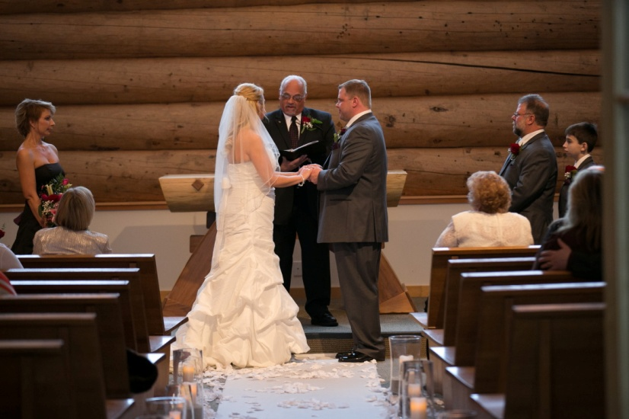



1
6

Discipleship

SUNDAY SCHOOL – For all ages at 9:45 am every Sunday.
ALL ABOARD! Keeping Kids on Track – (2 year old thru 6th grade) The children meet on Sunday at 9:45 am upstairs in the Education Building in the Children’s Worship Room. All children will be signed in with a secure KidCheck program. We will help you to register your child if you have not done so already.

FIRST BAPTIST CHURCH Student Ministries – On Wednesdays, the youth group meets for Bible study and games at 6:00 pm. All youth 7th through 12th grade are welcome to attend. For more information contact our Youth Ministry Coordinators, Andy and Hannah Ellis at 949-355-2780.

Ministry

s.

3

4
4
4

Announcements HOW DID YOU HEAR ABOUT FBC
Mrs. Jean Riley/30916 Soapmine Rd./256-9557/60-64 Yrs.

John & Carly Giilmore/27681 Linda Vista/953-5718/26-31 Yrs. Other
Looking for a home church.

Miss Jennifer Elam/751 Higgins Rd. #1/252-5082/26-31 Yrs. Friend

Miss Rebecca Nieto/751 Higgins Rd. #1/252-5082/26-31 Yrs. Friend

Kevin & Marie McArthur/29026 Gabilan St./590-9846/43-53 Yrs. Friend
Just moved here.

OUT OF TOWN VISITORS
Mr. & Mrs. Donald & Patricia Vester/24 Cobblestone Way W./Mobile, AL 36608/Traveling thru city.
Gustavo and Michelle Sanchez/5941 Milana Dr./Corona, CA 92880/Visiting

SUNDAY SCHOOL
Enrollment – 635 Attendance – 305 Members – 274 New Members – 6 Guests – 29

WORSHIP ATTENDANCE
8:30 Service 186
11:00 Service 327 = 513 + 7 on mission trip
No Evening Service 169
682

BUDGET OFFERING
General Fund: $9,001.75 Other: $1,558.65 Missions: $52.00

NEW MEMBERS/DECISIONS
Profession of Faith:
Rededication:
Want to join the church:
Joined the church-completed all requirements: J.R. & Lisa Lamb

BAPTIZED
J.R. Lamb
Lisa Lamb
s

NEEDED FOR WELCOME MINISTRY
The welcome ministry is seeking to acquire a golf cart (or two). The carts will be used to help transport folks from the parking lot to the worship area well as using them for security during services. If you have one you wish to donate or know of someone who has one, please contact Jim Webster at 760-447-5636.

SCRAP FOR MISSIONS
It’s time for Spring cleaning!! Let the Honduras Missions Team help you by gladly taking any of your scrap metal laying around. Contact Jim Webster at 760-447-5636 for a pick up date and time.

Missions and Evangelism

MEN’S BIBLE STUDY – The Men’s Bible Study has begun. We meet on Tuesdays, at 6:30 PM in the Worship Center, Pathfinders classroom. We are doing a study by Tony Evans called, “Kingdom Man”. All men are invited to attend. For information contact Ken DeVries at 760-559-6069.

Announcements HOW DID YOU HEAR ABOUT FBC
Mrs. Jean Riley/30916 Soapmine Rd./256-9557/60-64 Yrs.

John & Carly Giilmore/27681 Linda Vista/953-5718/26-31 Yrs. Other
Looking for a home church.

Miss Jennifer Elam/751 Higgins Rd. #1/252-5082/26-31 Yrs. Friend

Miss Rebecca Nieto/751 Higgins Rd. #1/252-5082/26-31 Yrs. Friend

Kevin & Marie McArthur/29026 Gabilan St./590-9846/43-53 Yrs. Friend
Just moved here.

OUT OF TOWN VISITORS
Mr. & Mrs. Donald & Patricia Vester/24 Cobblestone Way W./Mobile, AL 36608/Traveling thru city.
Gustavo and Michelle Sanchez/5941 Milana Dr./Corona, CA 92880/Visiting

SUNDAY SCHOOL
Enrollment – 635 Attendance – 305 Members – 274 New Members – 6 Guests – 29

WORSHIP ATTENDANCE
8:30 Service 186
11:00 Service 327 = 513 + 7 on mission trip
No Evening Service 169
682

BUDGET OFFERING
General Fund: $9,001.75 Other: $1,558.65 Missions: $52.00

NEW MEMBERS/DECISIONS
Profession of Faith:
Rededication:
Want to join the church:
Joined the church-completed all requirements: J.R. & Lisa Lamb

BAPTIZED
J.R. Lamb
Lisa Lamb
s

LADIES BIBLE STUDIES – The morning ladies Bible study group “Giggles and Lace” has concluded their study but if you would like to be a part of the next one, contact Sherrie DeVries at 760-253-2568.
**The evening Bible study group meets here at the church at 5:30 pm in the lower level of the education building. They are doing a study called, “Breaking Free” by Beth Moore. For more information contact Diane Bubier, 760-447-0093.

CHI ALPHA MISSION TOUR - Our Chi Alpha Singers have firmed up a commitment for their 25th annual Mission tour for summer, 2013. With the help of Ben Pate, we have been in contact with Ben Reid, pastor of Enchanted Hills Baptist Church in Tucson, Arizona. He and their church have given a “go” to host our group in June. Our students will lead Vacation Bible School programs in 2-3 separate apartment complexes. This approach to reaching children has been extremely successful. Instead of trying to get children to a particular church location, we go to where the children and families are living. Pastor Ben and his church have committed to prayer weekly for this ministry and are planning “prayer walks” over the possible locations. The potential for our students having a great impact in children’s lives is significant.
The Chi Alpha Mission tour is open to all 7th – 12th grade students. Dates for the mission tour are June 14-24. The choir meets every Sunday from 4:30 to 6:00 in the choir room. Contact Jerry for more information or simply attend a rehearsal to learn more.

CHURCH FAMILY NEWS
Sunday, March 24, 2013
Worship Services: 438
Sunday School: 146

Fellowship

